* 电路图

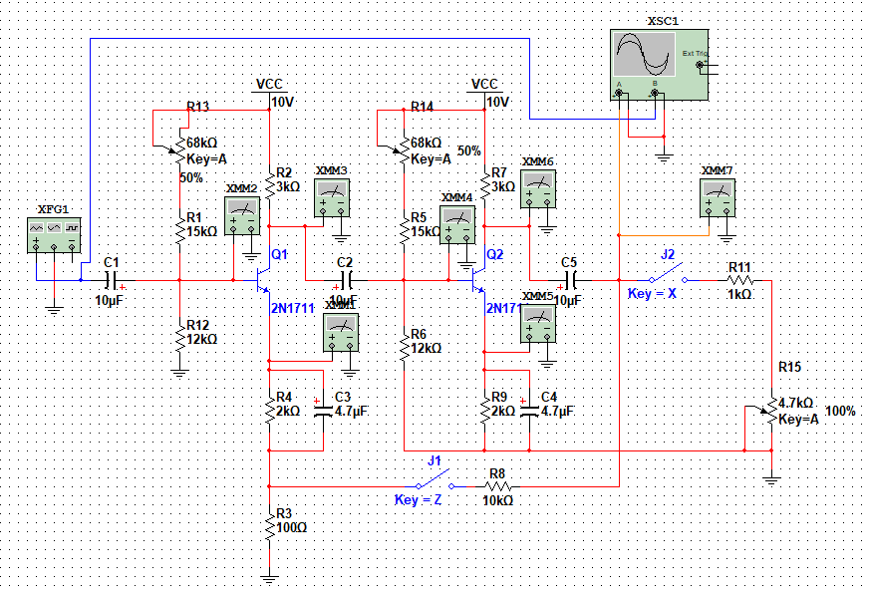

* 调整放大器静态工作点

|  |  |  |
| --- | --- | --- |
| 各级对地电压 | Q1 | Q2 |
| $V_{C}$ (V) | 5.427 | 6.056 |
| $V_{B}$ (V) | 3.650 | 3.812 |
| $V_{E}$ (V) | 3.036 | 3.030 |

* 电压串联负反馈对放大倍数的影响

|  |  |  |  |  |  |  |
| --- | --- | --- | --- | --- | --- | --- |
|  | $V_{O}$ (V) | $V_{RF1}$ (mV) | F | $$A_{V}$$ | $$A_{VF}$$ | |
| 计算值 | 实测值 |
| 无反馈 | 1.134 | / | / |  | / | / |
| 有反馈 | 0.188 | 1.342 |  | / |  |  |

* 负载变化对放大器放大倍数的影响

|  |  |  |  |  |  |  |  |
| --- | --- | --- | --- | --- | --- | --- | --- |
|  | $$R_{L}=4.7kΩ$$ | | $$R_{L}=3kΩ$$ | | $$dA_{V}/A_{V1}$$ | $$dA_{VF}/A_{VF1}$$ | |
| $V_{O}$ (V) | $A_{V1}$ 或 $A_{VF1}$ | $V_{O}$ (V) | $A_{V2}$ 或 $A_{VF2}$ | 计算值 | 实测值 |
| 有反馈 | 1.134 |  | 0.912 |  |  | / | / |
| 无反馈 | 0.295 |  | 0.266 |  | / |  |  |

* 电压串联负反馈对输入电阻的影响

|  |  |  |  |  |  |
| --- | --- | --- | --- | --- | --- |
|  | $V_{A}$ (mV) | $W_{1}$ (KΩ) | $r_{i}$ (KΩ) | $r_{iF}$ (KΩ) | |
| 计算值 | 实测值 |
| 无反馈 | 1.188 | 1 |  | / | / |
| 有反馈 | 1.342 | 1 | / |  |  |

* 电压串联负反馈对输入电阻的影响

|  |  |  |  |  |  |
| --- | --- | --- | --- | --- | --- |
|  | $$R_{L}=∞$$ $V_{O}$ (V) | $$R_{L}=4.7kΩ$$ $V_{O}$ (V) | $r_{O}$ (KΩ) | $r_{OF}$ (KΩ) | |
| 计算值 | 实测值 |
| 无反馈 | 2.110 | 1.472 |  | / | / |
| 有反馈 | 0.195 | 0.221 | / |  |  |